# **Name: Abdurrahman Qureshi**

# **Roll no: 210451**

## **Practical no 14: -**

**CODE:**

#include<iostream.h>

#include<conio.h>

class book

{

public:

char bkname[20],aname[20];

int price;

void getdata()

{

cout<<"Enter book name, author name and price: ";

cin>>bkname>>aname>>price;

}

void putdata()

{

cout<<"Book name: "<<bkname<<endl;

cout<<"Author name: "<<aname<<endl;

cout<<"Price: "<<price;

}

};

void main()

{

book b,*p;

clrscr();

p=&b;

p->getdata();

p->putdata();

getch();

}

**OUTPUT:**

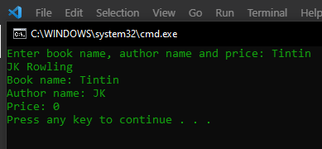

2.

**CODE:**

#include<iostream.h>

#include<conio.h>

class box

{

public:

int height, length,breadth;

float area,volume;

void getdata()

{

cout<<"Enter height, length and breadth: ";

cin>>height>>length>>breadth;

}

void putdata()

{

area=2*length*breadth+2*length*height+2*breadth*height;

volume=length*breadth*height;

cout<<"Area of box= "<<area<<endl;

cout<<"Volume of box= "<<volume;

}

};

void main()

{

box b,*p;

clrscr();

p=&b;

p->getdata();

p->putdata();

getch();

}

**OUTPUT:**

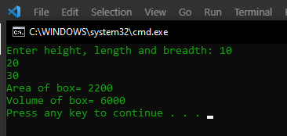

3.

**CODE:**

#include<iostream.h>

#include<conio.h>

class birthday

{

public:

int day,year;

char month[10];

void accept()

{

cout<<"Enter your birth date, month and year: ";

cin>>day>>month>>year;

}

void display()

{

cout<<"Birthday: "<<day<<"-"<<month<<"-"<<year<<endl;

}

};

void main()

{

int i;

birthday birth[5],*b;

clrscr();

b=&birth[0];

for(i=0;i<5;i++)

(b+i)->accept();

for(i=0;i<5;i++)

(b+i)->display();

getch();

}

**OUTPUT:**

